*Data Analytics Powered by Tableau*

***PROJECT TITLE***

Visualization Tool for Electric Vehicle Charge and Range Analysis



***TEAM LEADER:*** **HANSA G K**

***TEAM MEMBERS:* JAFFI J**

**JEBISHA LAWRENCE L**

**JEFNA J**

***TEAM ID:* NM2023TMID04060**

Project Report Template

**INTRODUCTION**



The Electric Vehicle has been receiving significantly more attention in recent years. Advances in both EV analytics and battery technologies have led to increased automotive market share. The modern mechatronic vehicle marries electrical storage and propulsion systems with electronic sensors, controls, and actuators, integrated closely with software, secure data transfer, and data analysis, to form a comprehensive transportation solution. Advances in all these areas have contributed to the overall rise of EV’s, but the common thread that runs through all these elements is data analytics.

**PURPOSE**

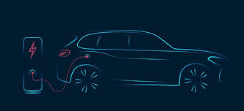

Electric vehicles use electricity to charge their batteries instead of using fossil fuels like petrol or diesel. The main purpose of data analysis is to understand the data and gain useful information so that the derived knowledge can help in decision making. The ultimate goal of data analysis is to convert raw data into actionable information that can inform decision making and drive business growth.

**EMPATHY MAP**

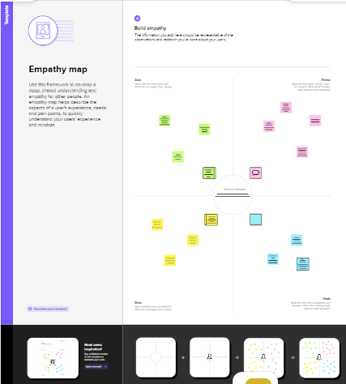

**IDEATION & BRAINSTORMING MAP**

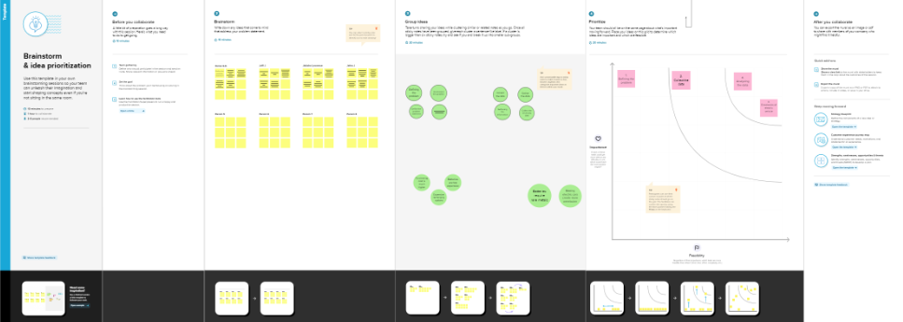

**RESULT**

**Dashboard**

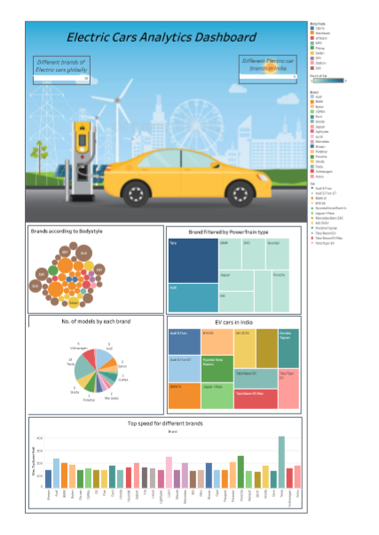

**Story**

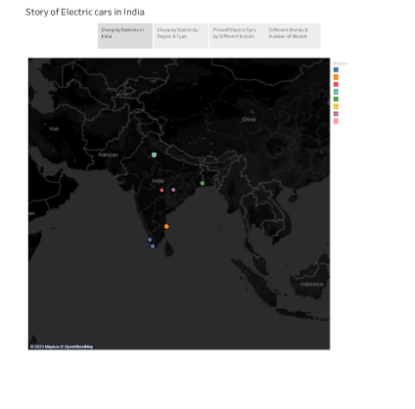

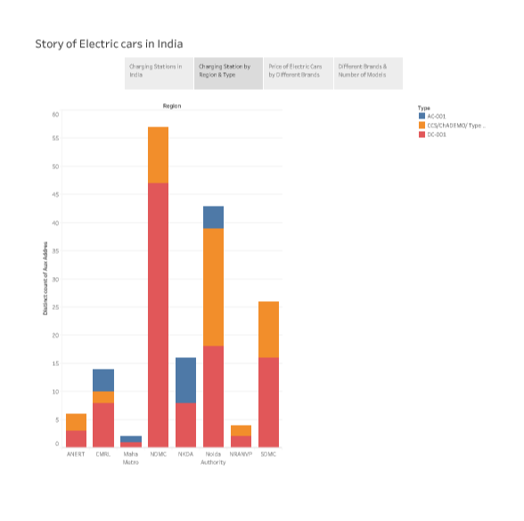

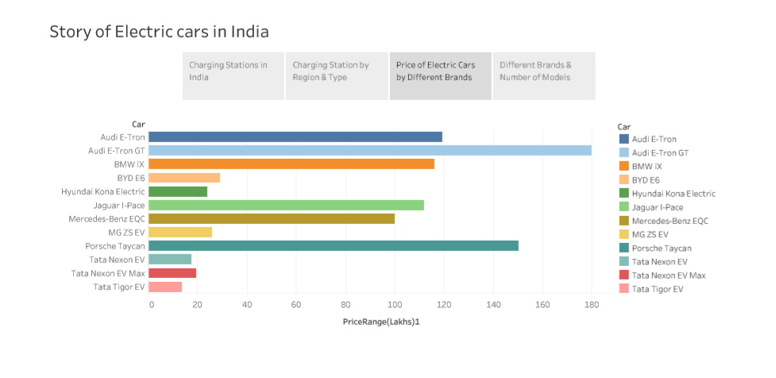

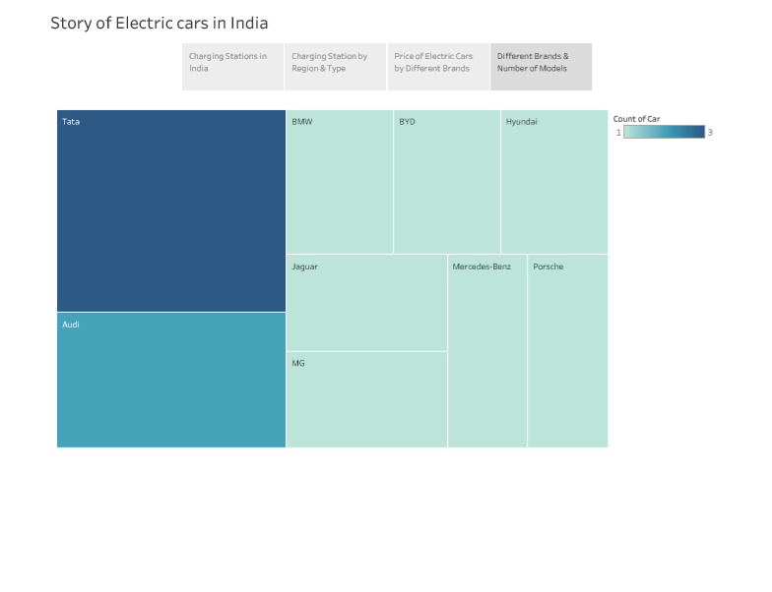

**Web Integration**

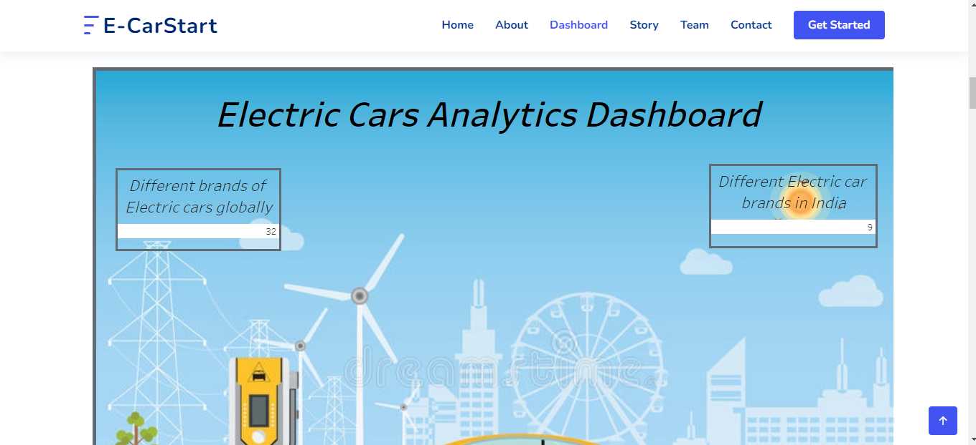

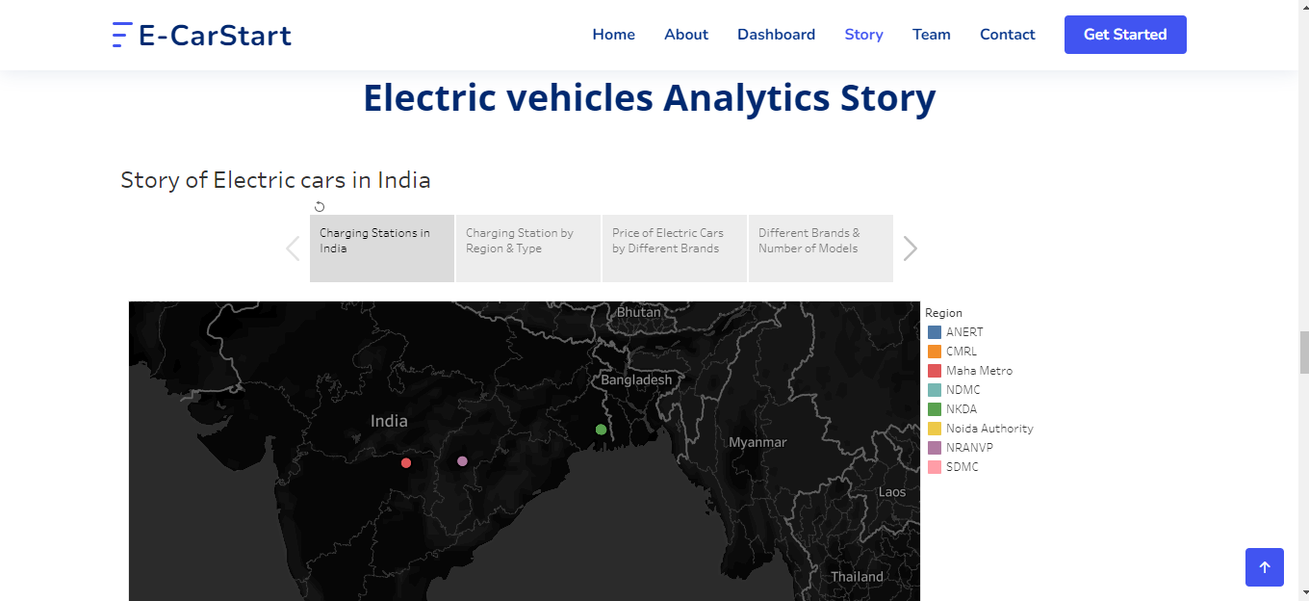

**ADVANTAGES & DISADVANTAGES**

Advantages:

* Better Performance
* Lower maintenance due to an efficient electric motor
* Environment friendly

Disadvantage:

* Battery expenses
* Slow charging
* Expensive recharging options

**APPLICATIONS**

* Logistics and delivery
* Web search or Internet web results
* Transportation
* Health care
* Education
* Manufacturing

**CONCLUSION**

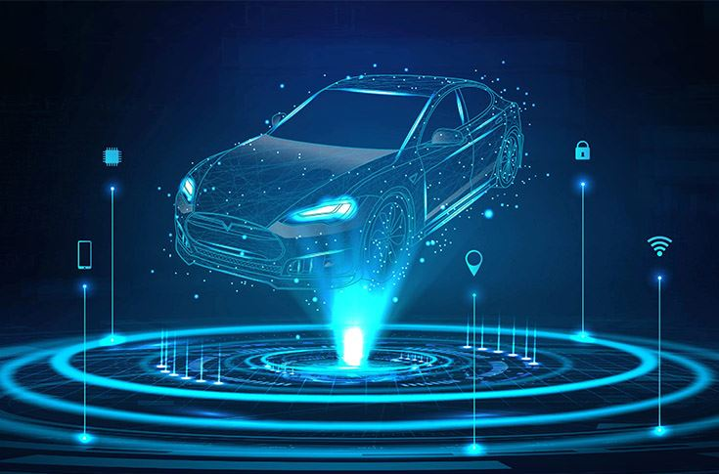

As more and more data is generated and collected, data analysis requires scalable, flexible and high performing tools to provide insights in a timely fashion. However, organizations are facing a growing big data environment, where new tools emerge and become outdated very quickly.

**FUTURE SCOPE**

The future scope of a data analyst is very promising, as the demand for professionals who can turn data into insights continues to grow. The increasing availability of data, combined with advances in technology and analytics, has created an environment in which data analysts are playing an increasingly important role in organizations of all sizes and industries. As organizations continue to embrace data-driven decision-making, the demand for data analysts is expected to remain high, and those with the right skills and experience will have many opportunities for career advancement and growth.

**SOURCE CODE**

<!DOCTYPE html>

<html lang="en">

<head>

  <meta charset="utf-8">

  <meta content="width=device-width, initial-scale=1.0" name="viewport">

  <title>Electric Cars Analytics</title>

  <meta content="" name="description">

  <meta content="" name="keywords">

  <!-- Favicons -->

  <link href="assets/img/favicon.png" rel="icon">

  <link href="assets/img/apple-touch-icon.png" rel="apple-touch-icon">

  <!-- Google Fonts -->

  <link href="https://fonts.googleapis.com/css?family=Open+Sans:300,300i,400,400i,600,600i,700,700i|Nunito:300,300i,400,400i,600,600i,700,700i|Poppins:300,300i,400,400i,500,500i,600,600i,700,700i" rel="stylesheet">

  <!-- Vendor CSS Files -->

  <link href="assets/vendor/aos/aos.css" rel="stylesheet">

  <link href="assets/vendor/bootstrap/css/bootstrap.min.css" rel="stylesheet">

  <link href="assets/vendor/bootstrap-icons/bootstrap-icons.css" rel="stylesheet">

  <link href="assets/vendor/glightbox/css/glightbox.min.css" rel="stylesheet">

  <link href="assets/vendor/remixicon/remixicon.css" rel="stylesheet">

  <link href="assets/vendor/swiper/swiper-bundle.min.css" rel="stylesheet">

  <!-- Template Main CSS File -->

  <link href="assets/css/style.css" rel="stylesheet">

  <!-- =======================================================

  * Template Name: FlexStart - v1.12.0

  * Template URL: https://bootstrapmade.com/flexstart-bootstrap-startup-template/

  * Author: BootstrapMade.com

  * License: https://bootstrapmade.com/license/

  ======================================================== -->

</head>

<body>

  <!-- ======= Header ======= -->

  <header id="header" class="header fixed-top">

    <div class="container-fluid container-xl d-flex align-items-center justify-content-between">

      <a href="index.html" class="logo d-flex align-items-center">

        <img src="assets/img/logo.png" alt="">

        <span>E-CarStart</span>

      </a>

      <nav id="navbar" class="navbar">

        <ul>

          <li><a class="nav-link scrollto active" href="#hero">Home</a></li>

          <li><a class="nav-link scrollto" href="#about">About</a></li>

          <li><a class="nav-link scrollto" href="#values">Dashboard</a></li>

          <li><a class="nav-link scrollto" href="#services">Story</a></li>

          <li><a class="nav-link scrollto" href="#team">Team</a></li>

          <li><a class="nav-link scrollto" href="#contact">Contact</a></li>

          <li><a class="getstarted scrollto" href="#about">Get Started</a></li>

        </ul>

        <i class="bi bi-list mobile-nav-toggle"></i>

      </nav><!-- .navbar -->

    </div>

  </header><!-- End Header -->

  <!-- ======= Hero Section ======= -->

  <section id="hero" class="hero d-flex align-items-center">

    <div class="container">

      <div class="row">

        <div class="col-lg-6 d-flex flex-column justify-content-center">

          <h1 data-aos="fade-up">We offer modern Analytics solutions for Electric Vehicles</h1>

          <div data-aos="fade-up" data-aos-delay="600">

            <div class="text-center text-lg-start">

              <a href="#about" class="btn-get-started scrollto d-inline-flex align-items-center justify-content-center align-self-center">

                <span>Get Started</span>

                <i class="bi bi-arrow-right"></i>

              </a>

            </div>

          </div>

        </div>

        <div class="col-lg-6 hero-img" data-aos="zoom-out" data-aos-delay="200">

          <img src="assets\img\12085817_20944306.jpg" class="img-fluid" alt="">

        </div>

      </div>

    </div>

  </section><!-- End Hero -->

  <main id="main">

    <!-- ======= About Section ======= -->

    <section id="about" class="about">

      <div class="container" data-aos="fade-up">

        <div class="row gx-0">

          <div class="col-lg-6 d-flex flex-column justify-content-center" data-aos="fade-up" data-aos-delay="200">

            <div class="content">

              <h3>E-Car Start</h3>

              <h2>E-Cart Start is a complete analytics tool for electric vehiles all over the world.</h2>

              <p>

                The Electric Vehicle (EV) is not new, but it has been receiving significantly more attention in recent years. Advances in both EV analytics and battery technologies have led to increased automotive market share.The modern mechatronic vehicle marries electrical storage and propulsion systems with electronic sensors, controls, and actuators, integrated closely with software, secure data transfer, and data analysis, to form a comprehensive transportation solution. Advances in all these areas have contributed to the overall rise of EV’s, but the common thread that runs through all these elements is data analytics.

              </p>

              <div class="text-center text-lg-start">

                <a href="#" class="btn-read-more d-inline-flex align-items-center justify-content-center align-self-center">

                  <span>Read More</span>

                  <i class="bi bi-arrow-right"></i>

                </a>

              </div>

            </div>

          </div>

          <div class="col-lg-6 d-flex align-items-center" data-aos="zoom-out" data-aos-delay="200">

            <img src="assets\img\EV.jpeg" class="img-fluid" alt="">

          </div>

        </div>

      </div>

    </section><!-- End About Section -->

    <!-- ======= Values Section ======= -->

    <section id="values" class="values">

      <div class="container" data-aos="fade-up">

        <header class="section-header">

          <h2>Dashboard</h2>

          <p>E-Car Start Analytics Dashboard</p>

        </header>

        <div class="row">

          <div class='tableauPlaceholder' id='viz1681491645248' style='position: relative'><noscript><a href='#'><img alt='Dashboard  ' src='https:&#47;&#47;public.tableau.com&#47;static&#47;images&#47;El&#47;ElectricCarsAnalytics_16814551559470&#47;Dashboard&#47;1_rss.png' style='border: none' /></a></noscript><object class='tableauViz'  style='display:none;'><param name='host_url' value='https%3A%2F%2Fpublic.tableau.com%2F' /> <param name='embed_code_version' value='3' /> <param name='site_root' value='' /><param name='name' value='ElectricCarsAnalytics_16814551559470&#47;Dashboard' /><param name='tabs' value='no' /><param name='toolbar' value='yes' /><param name='static_image' value='https:&#47;&#47;public.tableau.com&#47;static&#47;images&#47;El&#47;ElectricCarsAnalytics_16814551559470&#47;Dashboard&#47;1.png' /> <param name='animate_transition' value='yes' /><param name='display_static_image' value='yes' /><param name='display_spinner' value='yes' /><param name='display_overlay' value='yes' /><param name='display_count' value='yes' /><param name='language' value='en-US' /></object></div>                <script type='text/javascript'>                    var divElement = document.getElementById('viz1681491645248');                    var vizElement = divElement.getElementsByTagName('object')[0];                    if ( divElement.offsetWidth > 800 ) { vizElement.style.width='1320px';vizElement.style.height='2027px';} else if ( divElement.offsetWidth > 500 ) { vizElement.style.width='1320px';vizElement.style.height='2027px';} else { vizElement.style.width='100%';vizElement.style.height='2377px';}                     var scriptElement = document.createElement('script');                    scriptElement.src = 'https://public.tableau.com/javascripts/api/viz_v1.js';                    vizElement.parentNode.insertBefore(scriptElement, vizElement);                </script>

        </div>

      </div>

    </section><!-- End Values Section -->

    <!-- ======= Features Section ======= -->

    <section id="features" class="features">

      <div class="container" data-aos="fade-up">

        <header class="section-header">

          <h2>Features</h2>

          <p>There are many different features of our project</p>

        </header>

        <div class="row">

          <div class="col-lg-6">

            <img src="assets/img/features.png" class="img-fluid" alt="">

          </div>

          <div class="col-lg-6 mt-5 mt-lg-0 d-flex">

            <div class="row align-self-center gy-4">

              <div class="col-md-6" data-aos="zoom-out" data-aos-delay="200">

                <div class="feature-box d-flex align-items-center">

                  <i class="bi bi-check"></i>

                  <h3>Analyse the currect stats</h3>

                </div>

              </div>

              <div class="col-md-6" data-aos="zoom-out" data-aos-delay="300">

                <div class="feature-box d-flex align-items-center">

                  <i class="bi bi-check"></i>

                  <h3>Get to know EV more</h3>

                </div>

              </div>

              <div class="col-md-6" data-aos="zoom-out" data-aos-delay="400">

                <div class="feature-box d-flex align-items-center">

                  <i class="bi bi-check"></i>

                  <h3>Know about Charging Stations</h3>

                </div>

              </div>

              <div class="col-md-6" data-aos="zoom-out" data-aos-delay="500">

                <div class="feature-box d-flex align-items-center">

                  <i class="bi bi-check"></i>

                  <h3>Top performing Brands</h3>

                </div>

              </div>

              <div class="col-md-6" data-aos="zoom-out" data-aos-delay="600">

                <div class="feature-box d-flex align-items-center">

                  <i class="bi bi-check"></i>

                  <h3>different brands in India</h3>

                </div>

              </div>

              <div class="col-md-6" data-aos="zoom-out" data-aos-delay="700">

                <div class="feature-box d-flex align-items-center">

                  <i class="bi bi-check"></i>

                  <h3>different brands Globally</h3>

                </div>

              </div>

            </div>

          </div>

        </div> <!-- / row -->

        <!-- Feature Tabs -->

        <div class="row feture-tabs" data-aos="fade-up">

          <div class="col-lg-6">

            <h3>Overview of Electric Vehicle Sector</h3>

            <!-- Tabs -->

            <ul class="nav nav-pills mb-3">

              <li>

                <a class="nav-link active" data-bs-toggle="pill" href="#tab1">Overview</a>

              </li>

              <li>

                <a class="nav-link active" data-bs-toggle="pill" href="#tab2">Pricing</a>

              </li>

            </ul><!-- End Tabs -->

            <!-- Tab Content -->

            <div class="tab-content">

              <div class="tab-pane fade show active" id="tab1">

                <p>The supply of fossil fuels is constantly decreasing. The situation is very alarming. It is time for the world to slowly adapt to electric vehicles. </p>

                <div class="d-flex align-items-center mb-2">

                  <i class="bi bi-check2"></i>

                  <h4>A lot of change needs to happen</h4>

                </div>

                <p>Major carmakers like Tesla and Porsche manufacture many electric vehicles. </p>

                <div class="d-flex align-items-center mb-2">

                  <i class="bi bi-check2"></i>

                  <h4> The improvement of battery technology in recent years has led to the higher popularity of electric vehicles.</h4>

                </div>

                <p>Buying an electric vehicle can be a great choice for consumers. The drive quality, low noise levels, and convenience are really great.</p>

              </div><!-- End Tab 1 Content -->

              <div class="tab-pane fade show" id="tab2">

                <p> In the United States, one year of driving a petrol car can cost from 1500 USD to 2500 USD.</p>

                <div class="d-flex align-items-center mb-2">

                  <i class="bi bi-check2"></i>

                  <h4>On the other hand, the driving cost of Electric Vehicles is 500 USD. Electric cars are more preferable.</h4>

                </div>

                <p>The maintenance cost of electric vehicles is also very low. They are economical to maintain.</p>

                <div class="d-flex align-items-center mb-2">

                  <i class="bi bi-check2"></i>

                  <h4>The energy conversion efficiency of electric vehicles is also high.</h4>

                </div>

                <p>Electric vehicles use 60-70% of electrical energy. On the other hand, vehicles based on internal combustion engines have an efficiency of 18-22% only.The energy cost of manufacturing an electric vehicle is also very high, but considering everything and the fact that charging electric vehicles is very cheap, EVs are a great option. Manufacturing batteries is an important task in the production of Electric vehicles.</p>

              </div><!-- End Tab 2 Content -->

            </div>

          </div>

          <div class="col-lg-6">

            <img src="assets\img\e-car.jpg" style="height: 80%; width: 100%;" class="img-fluid" alt="">

          </div>

        </div><!-- End Feature Tabs -->

      </div>

    </section><!-- End Features Section -->

    <!-- ======= Services Section ======= -->

    <section id="services" class="services">

      <div class="container" data-aos="fade-up">

        <header class="section-header">

          <h2>Story</h2>

          <p>Electric vehicles Analytics Story</p>

        </header>

        <div class="row gy-4">

          <div class='tableauPlaceholder' id='viz1681490253044' style='position: relative'><noscript><a href='#'><img alt='Story of Electric cars in India ' src='https:&#47;&#47;public.tableau.com&#47;static&#47;images&#47;X3&#47;X3GQQCK9Y&#47;1_rss.png' style='border: none' /></a></noscript><object class='tableauViz'  style='display:none;'><param name='host_url' value='https%3A%2F%2Fpublic.tableau.com%2F' /> <param name='embed_code_version' value='3' /> <param name='path' value='shared&#47;X3GQQCK9Y' /> <param name='toolbar' value='yes' /><param name='static_image' value='https:&#47;&#47;public.tableau.com&#47;static&#47;images&#47;X3&#47;X3GQQCK9Y&#47;1.png' /> <param name='animate_transition' value='yes' /><param name='display_static_image' value='yes' /><param name='display_spinner' value='yes' /><param name='display_overlay' value='yes' /><param name='display_count' value='yes' /><param name='language' value='en-US' /></object></div>                <script type='text/javascript'>                    var divElement = document.getElementById('viz1681490253044');                    var vizElement = divElement.getElementsByTagName('object')[0];                    vizElement.style.width='1016px';vizElement.style.height='991px';                    var scriptElement = document.createElement('script');                    scriptElement.src = 'https://public.tableau.com/javascripts/api/viz_v1.js';                    vizElement.parentNode.insertBefore(scriptElement, vizElement);                </script>

        </div>

      </div>

    </section><!-- End Services Section -->

    <!-- ======= Testimonials Section ======= -->

    <section id="testimonials" class="testimonials">

      <div class="container" data-aos="fade-up">

        <header class="section-header">

          <h2>Testimonials</h2>

          <p>What they are saying about us</p>

        </header>

        <div class="testimonials-slider swiper" data-aos="fade-up" data-aos-delay="200">

          <div class="swiper-wrapper">

            <div class="swiper-slide">

              <div class="testimonial-item">

                <div class="stars">

                  <i class="bi bi-star-fill"></i><i class="bi bi-star-fill"></i><i class="bi bi-star-fill"></i><i class="bi bi-star-fill"></i><i class="bi bi-star-fill"></i>

                </div>

                <p>

                  Proin iaculis purus consequat sem cure digni ssim donec porttitora entum suscipit rhoncus. Accusantium quam, ultricies eget id, aliquam eget nibh et. Maecen aliquam, risus at semper.

                </p>

                <div class="profile mt-auto">

                  <img src="assets/img/testimonials/testimonials-1.jpg" class="testimonial-img" alt="">

                  <h3>Saul Goodman</h3>

                  <h4>Ceo &amp; Founder</h4>

                </div>

              </div>

            </div><!-- End testimonial item -->

            <div class="swiper-slide">

              <div class="testimonial-item">

                <div class="stars">

                  <i class="bi bi-star-fill"></i><i class="bi bi-star-fill"></i><i class="bi bi-star-fill"></i><i class="bi bi-star-fill"></i><i class="bi bi-star-fill"></i>

                </div>

                <p>

                  Export tempor illum tamen malis malis eram quae irure esse labore quem cillum quid cillum eram malis quorum velit fore eram velit sunt aliqua noster fugiat irure amet legam anim culpa.

                </p>

                <div class="profile mt-auto">

                  <img src="assets/img/testimonials/testimonials-2.jpg" class="testimonial-img" alt="">

                  <h3>Sara Wilsson</h3>

                  <h4>Designer</h4>

                </div>

              </div>

            </div><!-- End testimonial item -->

            <div class="swiper-slide">

              <div class="testimonial-item">

                <div class="stars">

                  <i class="bi bi-star-fill"></i><i class="bi bi-star-fill"></i><i class="bi bi-star-fill"></i><i class="bi bi-star-fill"></i><i class="bi bi-star-fill"></i>

                </div>

                <p>

                  Enim nisi quem export duis labore cillum quae magna enim sint quorum nulla quem veniam duis minim tempor labore quem eram duis noster aute amet eram fore quis sint minim.

                </p>

                <div class="profile mt-auto">

                  <img src="assets/img/testimonials/testimonials-3.jpg" class="testimonial-img" alt="">

                  <h3>Jena Karlis</h3>

                  <h4>Store Owner</h4>

                </div>

              </div>

            </div><!-- End testimonial item -->

            <div class="swiper-slide">

              <div class="testimonial-item">

                <div class="stars">

                  <i class="bi bi-star-fill"></i><i class="bi bi-star-fill"></i><i class="bi bi-star-fill"></i><i class="bi bi-star-fill"></i><i class="bi bi-star-fill"></i>

                </div>

                <p>

                  Fugiat enim eram quae cillum dolore dolor amet nulla culpa multos export minim fugiat minim velit minim dolor enim duis veniam ipsum anim magna sunt elit fore quem dolore labore illum veniam.

                </p>

                <div class="profile mt-auto">

                  <img src="assets/img/testimonials/testimonials-4.jpg" class="testimonial-img" alt="">

                  <h3>Matt Brandon</h3>

                  <h4>Freelancer</h4>

                </div>

              </div>

            </div><!-- End testimonial item -->

            <div class="swiper-slide">

              <div class="testimonial-item">

                <div class="stars">

                  <i class="bi bi-star-fill"></i><i class="bi bi-star-fill"></i><i class="bi bi-star-fill"></i><i class="bi bi-star-fill"></i><i class="bi bi-star-fill"></i>

                </div>

                <p>

                  Quis quorum aliqua sint quem legam fore sunt eram irure aliqua veniam tempor noster veniam enim culpa labore duis sunt culpa nulla illum cillum fugiat legam esse veniam culpa fore nisi cillum quid.

                </p>

                <div class="profile mt-auto">

                  <img src="assets/img/testimonials/testimonials-5.jpg" class="testimonial-img" alt="">

                  <h3>John Larson</h3>

                  <h4>Entrepreneur</h4>

                </div>

              </div>

            </div><!-- End testimonial item -->

          </div>

          <div class="swiper-pagination"></div>

        </div>

      </div>

    </section><!-- End Testimonials Section -->

    <!-- ======= Team Section ======= -->

    <section id="team" class="team">

      <div class="container" data-aos="fade-up">

        <header class="section-header">

          <h2>Team</h2>

          <p>Our hard working team</p>

        </header>

        <div class="row gy-4">

          <div class="col-lg-3 col-md-6 d-flex align-items-stretch" data-aos="fade-up" data-aos-delay="100">

            <div class="member">

              <div class="member-img">

                <img src="assets/img/team/team-1.jpg" class="img-fluid" alt="">

                <div class="social">

                  <a href=""><i class="bi bi-twitter"></i></a>

                  <a href=""><i class="bi bi-facebook"></i></a>

                  <a href=""><i class="bi bi-instagram"></i></a>

                  <a href=""><i class="bi bi-linkedin"></i></a>

                </div>

              </div>

              <div class="member-info">

                <h4>Walter White</h4>

                <span>Chief Executive Officer</span>

                <p>Velit aut quia fugit et et. Dolorum ea voluptate vel tempore tenetur ipsa quae aut. Ipsum exercitationem iure minima enim corporis et voluptate.</p>

              </div>

            </div>

          </div>

          <div class="col-lg-3 col-md-6 d-flex align-items-stretch" data-aos="fade-up" data-aos-delay="200">

            <div class="member">

              <div class="member-img">

                <img src="assets/img/team/team-2.jpg" class="img-fluid" alt="">

                <div class="social">

                  <a href=""><i class="bi bi-twitter"></i></a>

                  <a href=""><i class="bi bi-facebook"></i></a>

                  <a href=""><i class="bi bi-instagram"></i></a>

                  <a href=""><i class="bi bi-linkedin"></i></a>

                </div>

              </div>

              <div class="member-info">

                <h4>Sarah Jhonson</h4>

                <span>Product Manager</span>

                <p>Quo esse repellendus quia id. Est eum et accusantium pariatur fugit nihil minima suscipit corporis. Voluptate sed quas reiciendis animi neque sapiente.</p>

              </div>

            </div>

          </div>

          <div class="col-lg-3 col-md-6 d-flex align-items-stretch" data-aos="fade-up" data-aos-delay="300">

            <div class="member">

              <div class="member-img">

                <img src="assets/img/team/team-3.jpg" class="img-fluid" alt="">

                <div class="social">

                  <a href=""><i class="bi bi-twitter"></i></a>

                  <a href=""><i class="bi bi-facebook"></i></a>

                  <a href=""><i class="bi bi-instagram"></i></a>

                  <a href=""><i class="bi bi-linkedin"></i></a>

                </div>

              </div>

              <div class="member-info">

                <h4>William Anderson</h4>

                <span>CTO</span>

                <p>Vero omnis enim consequatur. Voluptas consectetur unde qui molestiae deserunt. Voluptates enim aut architecto porro aspernatur molestiae modi.</p>

              </div>

            </div>

          </div>

          <div class="col-lg-3 col-md-6 d-flex align-items-stretch" data-aos="fade-up" data-aos-delay="400">

            <div class="member">

              <div class="member-img">

                <img src="assets/img/team/team-4.jpg" class="img-fluid" alt="">

                <div class="social">

                  <a href=""><i class="bi bi-twitter"></i></a>

                  <a href=""><i class="bi bi-facebook"></i></a>

                  <a href=""><i class="bi bi-instagram"></i></a>

                  <a href=""><i class="bi bi-linkedin"></i></a>

                </div>

              </div>

              <div class="member-info">

                <h4>Amanda Jepson</h4>

                <span>Accountant</span>

                <p>Rerum voluptate non adipisci animi distinctio et deserunt amet voluptas. Quia aut aliquid doloremque ut possimus ipsum officia.</p>

              </div>

            </div>

          </div>

        </div>

      </div>

    </section><!-- End Team Section -->

    <!-- ======= Contact Section ======= -->

    <section id="contact" class="contact">

      <div class="container" data-aos="fade-up">

        <header class="section-header">

          <h2>Contact</h2>

          <p>Contact Us</p>

        </header>

        <div class="row gy-4">

          <div class="col-lg-6">

            <div class="row gy-4">

              <div class="col-md-6">

                <div class="info-box">

                  <i class="bi bi-geo-alt"></i>

                  <h3>Address</h3>

                  <p>The Smartbridge<br>Hyderabad, Telangana</p>

                </div>

              </div>

              <div class="col-md-6">

                <div class="info-box">

                  <i class="bi bi-telephone"></i>

                  <h3>Call Us</h3>

                  <p>+1 5589 55488 55<br>+1 6678 254445 41</p>

                </div>

              </div>

              <div class="col-md-6">

                <div class="info-box">

                  <i class="bi bi-envelope"></i>

                  <h3>Email Us</h3>

                  <p>info@example.com<br>contact@example.com</p>

                </div>

              </div>

              <div class="col-md-6">

                <div class="info-box">

                  <i class="bi bi-clock"></i>

                  <h3>Open Hours</h3>

                  <p>Monday - Friday<br>9:00AM - 07:00PM</p>

                </div>

              </div>

            </div>

          </div>

          <div class="col-lg-6">

            <div class="mapouter">

              <div class="gmap_canvas">

                <iframe src="https://www.google.com/maps/embed?pb=!1m18!1m12!1m3!1d3806.4996128125663!2d78.357789414877!3d17.435785388049602!2m3!1f0!2f0!3f0!3m2!1i1024!2i768!4f13.1!3m3!1m2!1s0x3bcb93ccf4ea7cc1%3A0xebff7843c5e1e33f!2sStacknexus%20Technologies%20Pvt%20Ltd!5e0!3m2!1sen!2sin!4v1671649820075!5m2!1sen!2sin" width="600" height="450" style="border:0;" allowfullscreen="" loading="lazy" referrerpolicy="no-referrer-when-downgrade"></iframe>

              </div>

              <style>.mapouter{position:relative;text-align:right;width:600px;height:400px;}.gmap_canvas {overflow:hidden;background:none!important;width:600px;height:400px;}.gmap_iframe {width:600px!important;height:400px!important;}</style>

            </div>

          </div>

        </div>

      </div>

    </section><!-- End Contact Section -->

  </main><!-- End #main -->

  <!-- ======= Footer ======= -->

  <footer id="footer" class="footer">

    <div class="footer-top">

      <div class="container">

        <div class="row gy-4">

          <div class="col-lg-5 col-md-12 footer-info">

            <a href="index.html" class="logo d-flex align-items-center">

              <img src="assets/img/logo.png" alt="">

              <span>E-CarStart</span>

            </a>

            <p>We offer modern Analytics solutions for Electric Vehicles.</p>

            <div class="social-links mt-3">

              <a href="#" class="twitter"><i class="bi bi-twitter"></i></a>

              <a href="#" class="facebook"><i class="bi bi-facebook"></i></a>

              <a href="#" class="instagram"><i class="bi bi-instagram"></i></a>

              <a href="#" class="linkedin"><i class="bi bi-linkedin"></i></a>

            </div>

          </div>

          <div class="col-lg-2 col-6 footer-links">

            <h4>Useful Links</h4>

            <ul>

              <li><i class="bi bi-chevron-right"></i> <a href="#">Home</a></li>

              <li><i class="bi bi-chevron-right"></i> <a href="#">About us</a></li>

              <li><i class="bi bi-chevron-right"></i> <a href="#">Services</a></li>

              <li><i class="bi bi-chevron-right"></i> <a href="#">Dashboard</a></li>

              <li><i class="bi bi-chevron-right"></i> <a href="#">Story</a></li>

            </ul>

          </div>

          <div class="col-lg-2 col-6 footer-links">

            <h4>Our Services</h4>

            <ul>

              <li><i class="bi bi-chevron-right"></i> <a href="https://www.thesmartbridge.com/">Web Design</a></li>

              <li><i class="bi bi-chevron-right"></i> <a href="https://www.thesmartbridge.com/">Web Development</a></li>

              <li><i class="bi bi-chevron-right"></i> <a href="https://www.thesmartbridge.com/">Product Management</a></li>

              <li><i class="bi bi-chevron-right"></i> <a href="https://www.thesmartbridge.com/">Marketing</a></li>

              <li><i class="bi bi-chevron-right"></i> <a href="https://www.thesmartbridge.com/">Graphic Design</a></li>

            </ul>

          </div>

          <div class="col-lg-3 col-md-12 footer-contact text-center text-md-start">

            <h4>Contact Us</h4>

            <p>

              The Smartbridge <br>

              Hyderabad<br>

              Telangana<br><br>

              <strong>Phone:</strong> +1 5589 55488 55<br>

              <strong>Email:</strong> info@example.com<br>

            </p>

          </div>

        </div>

      </div>

    </div>

    <div class="container">

      <div class="copyright">

        &copy; Copyright <strong><span>Smartbridge</span></strong>. All Rights Reserved

      </div>

    </div>

  </footer><!-- End Footer -->

  <a href="#" class="back-to-top d-flex align-items-center justify-content-center"><i class="bi bi-arrow-up-short"></i></a>

  <!-- Vendor JS Files -->

  <script src="assets/vendor/purecounter/purecounter_vanilla.js"></script>

  <script src="assets/vendor/aos/aos.js"></script>

  <script src="assets/vendor/bootstrap/js/bootstrap.bundle.min.js"></script>

  <script src="assets/vendor/glightbox/js/glightbox.min.js"></script>

  <script src="assets/vendor/isotope-layout/isotope.pkgd.min.js"></script>

  <script src="assets/vendor/swiper/swiper-bundle.min.js"></script>

  <script src="assets/vendor/php-email-form/validate.js"></script>

  <!-- Template Main JS File -->

  <script src="assets/js/main.js"></script>

</body>

</html>

THANK YOU